

NETFLIX
TILES DATA ANALYSIS
DASHBOARD
An interactive Netflix dashboard built with Python to analyze content trends, ratings, genres, and release patterns through data visualization.


DATASET INFORMATION

- Source : Kaggle
- Dataset : Netflix Titles
- Rows : 18,036
- Columns : 24
- Type : Movies & TV Shows
- File : Netflix_Merged.csv(Final Merged Dataset)

WORKFLOW

Data Collection
Data Cleaning
Data Merging
Exploratory Data Analysis
Business Insights
Data Visualization
Interactive Dashboard

TECHNOLOGIES USED
- Python
- Pandas
- NumPy
- Matplotlib
- Seaborn
- Streamlit

KEY FEATURES

- Data Cleaning and Preprocessing
- Dataset Merging
- Exploratory Data Analysis
- Business Insights
- Interactive KPI Dashboard
- Multiple Data Visualization
- Interactive Streamlit Application


DATA CLEANING SUMMARY
- Removed Duplicates
- Handled Missing Values
- Data Types Corrections
- Text Cleaning
- Merged Datasets
FINAL MERGED DATASET
Total Rows | 18,036
Total Columns | 18

COLUMNS IN FINAL DATASET
id | seasons
title | imdb_id
type | imdb_score
description | imdb_votes
release_year | tmdb_popularities
age_certification | tmdb_score
runtime | name
genres | character
production_countries | role
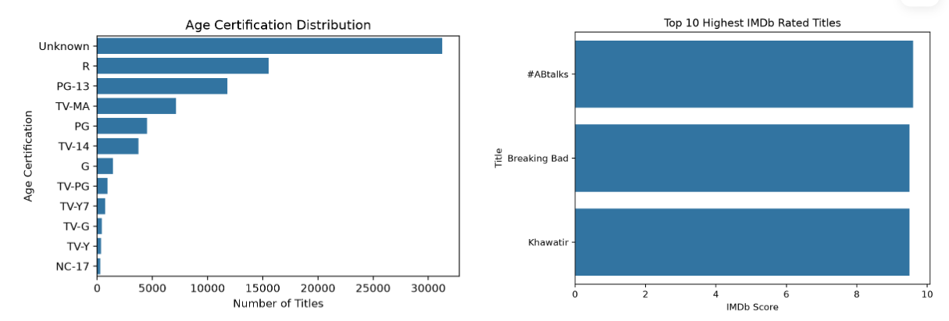
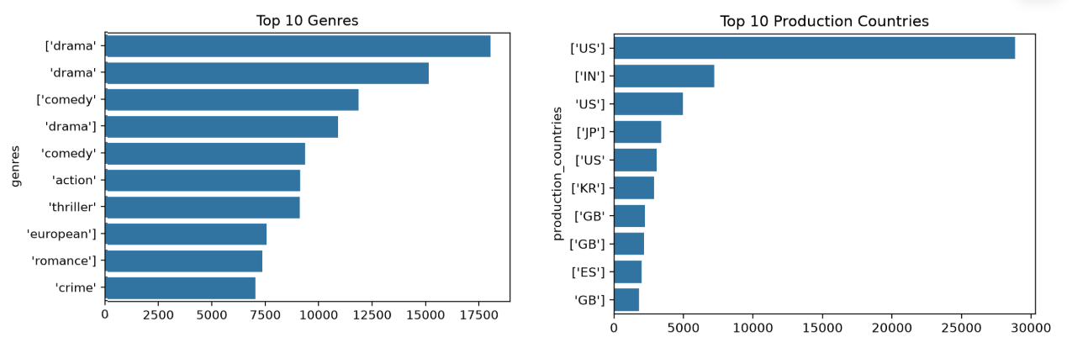
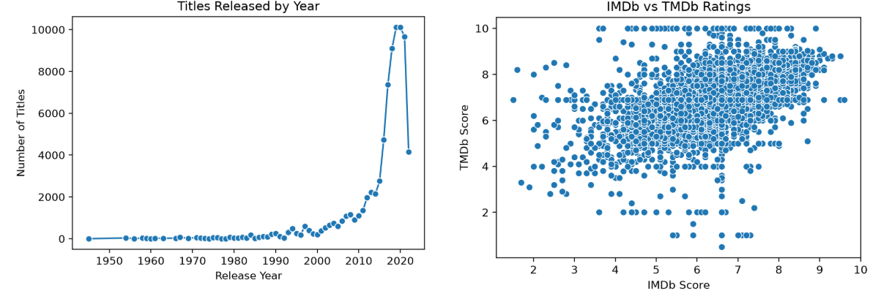
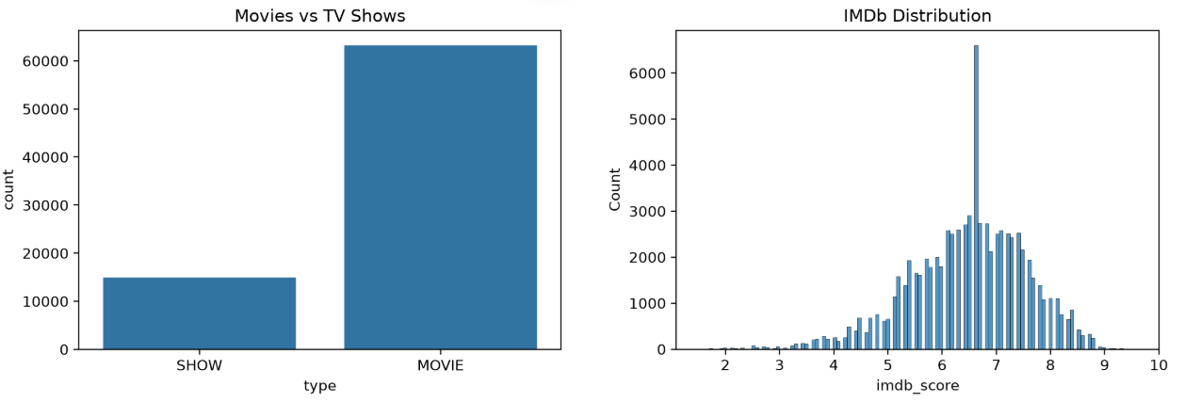
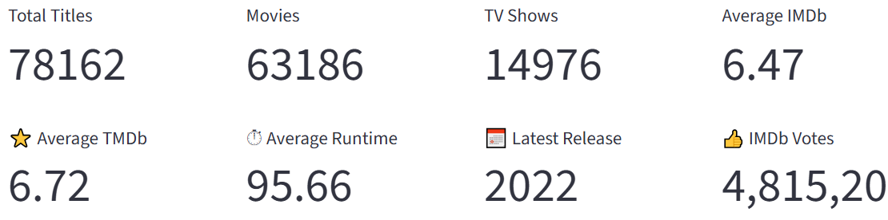
INTERACTIVE DASHBOARD PREVIEW

KEY INSIGHTS

- Netflix's catalog is dominated by Movies, accounting for over 80% of all titles.
- The United States is the leading production country, followed by India.
- Drama and Comedy are the most frequently occurring genres.
- Netflix experienced rapid catalog growth after 2015, reaching its highest volume around 2019–2021.
- Netflix experienced rapid catalog growth after 2015, reaching its highest volume around 2019–2021.
- The average IMDb and TMDb ratings are 6.47 and 6.72, indicating generally well-received content.
- IMDb and TMDb ratings show a clear positive relationship, suggesting consistency across rating platforms.
- The average runtime is approximately 96 minutes, indicating feature-length content dominates the platform.
- Breaking Bad, #ABtalks, and Khawatir are among the highest-rated titles in the dataset.

SKILLS DEMOSTRATED
- Python
- Pandas
- NumPy
- Matplotlib
- Seaborn
- Streamlit
- Exploratory Data Analysis
- Data Cleaning
- Data Visualization
- Dashboard Visualization

